Which of the following structure is the structure of phenol?
A.
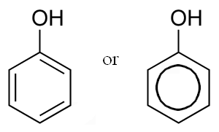
B.
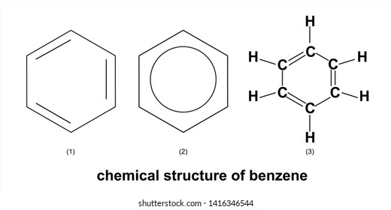
C.
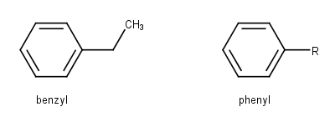
D.
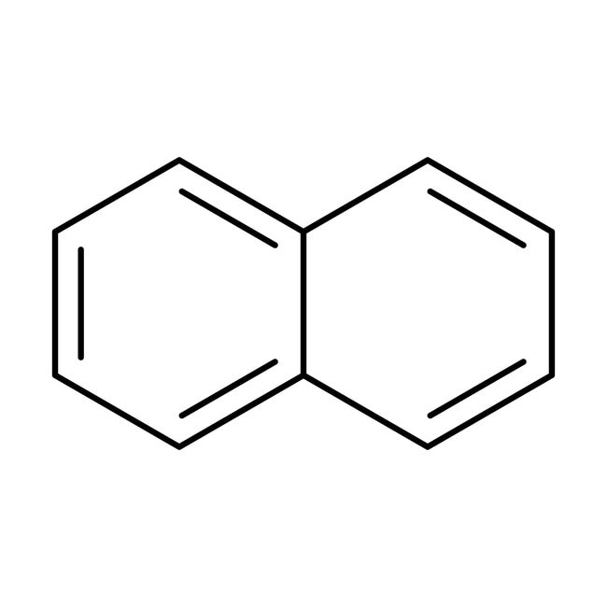
ANSWER: A
Phenol is also known as:
A. Formalin
B. Naphthalene
C. Carbolic acid
D. Cresol
ANSWER: C
Which compound is also known by the name of carbolic acid?
A. $C_{2}H_{2}OH$
B. $H_{2}CO_{3}$
C. $C_{6}H_{5}OH$
D. $H_{3}PO_{3}$
ANSWER: C
2,4,6-trinitro phenol is also known as ________ .
A. Catechol
B. Resorcinol
C. Picric acid
D. Hydroquinone
ANSWER: C
The following structure represents:

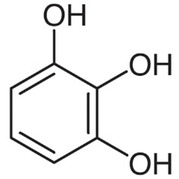
A. Catechol
B. Resorcinol
C. Pyrogallol
D. Hydroquinone
ANSWER: C
IUPAC name of hydroquinone is:
A. 4-methyl phenol
B. Benzene-1, 4-diol
C. Benzene-1, 3-diol
D. 2, 4-diol benzene
ANSWER: B
It is known as m-cresol.
A. 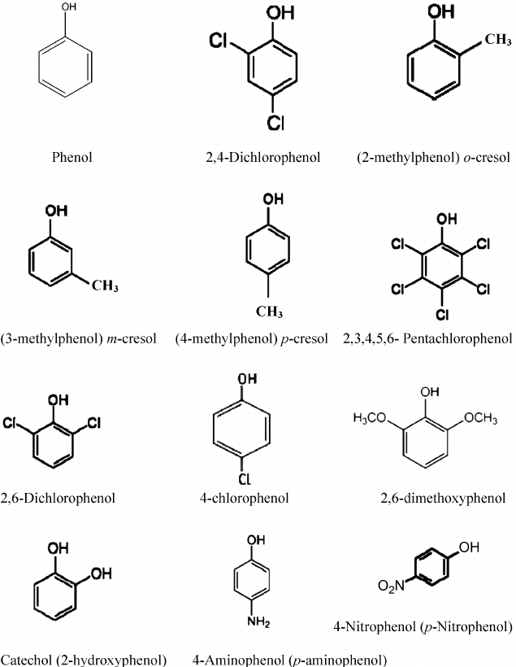
B. 
C. 
D. 
ANSWER: C

Which statement is correct about the acidic behavior of phenol?
A. It readily dissolve in alkalis
B. It is too weak to affect litmus paper
C. It is too weak to evolve $CO_{2}$
D. All of these
ANSWER: D
Disassociation constant value of phenol is:
A. $1.5×{10}^{-10}$
B. $1.7×{10}^{-5}$
C. $1.3×{10}^{-10}$
D. $1.8×{10}^{-3}$
ANSWER: C
It is known as o-cresol.
A. 
B. 
C. 
D. 
ANSWER: A

Acidic nature of phenol is due to:
A. Hydroxyl group
B. Aromatic ring
C. Phenoxide
D. Double bond
ANSWER: C
Which of the following order of acidic strength is correct?
A. Phenol > carboxylic acid > water > alcohol
B. Carboxylic acid > phenol > water > alcohol
C. Alcohol > Phenol > carboxylic acid > water
D. Water > alcohol > phenol > carboxylic acid
ANSWER: B
Phenols are more acidic than _________.
A. Ethanol
B. Formic acid
C. Ethanoic acid
D. Propanoic acid
ANSWER: A
The other name of Phenol is
A. Aliphatic Alcohol
B. Aromatic Alcohol
C. Catechol
D. Both B and C
ANSWER: B
It is known as p-cresol.
A. 
B. 
C. 
D. 
ANSWER: D

